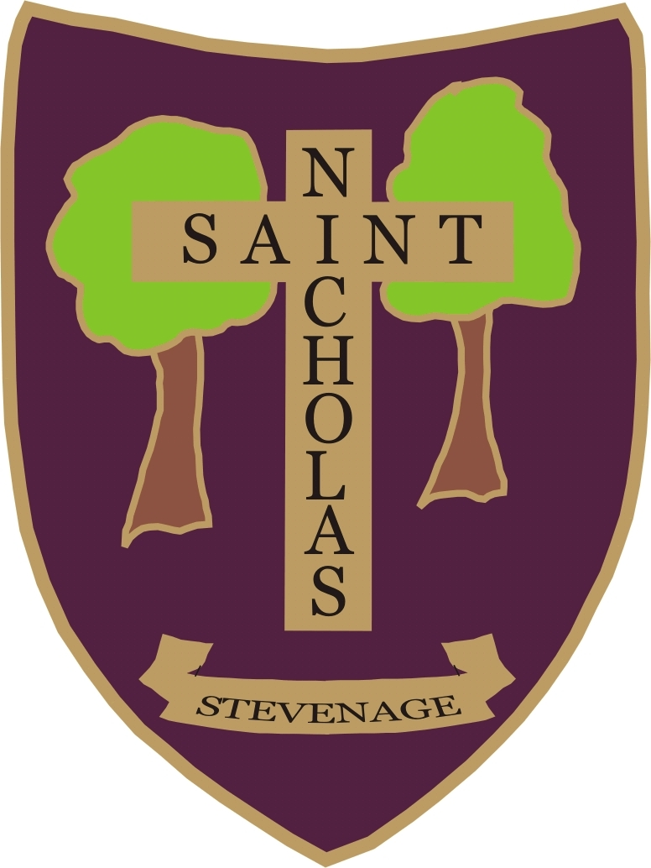 | Stevenage St Nicholas Primary School and Nursery  Learning, Living, Loving in God’s Family  SUPPLEMENTARY INFORMATION FORM 2024-25  If applying under categories 4, 5 or 6  Please complete in block capitals and  return this form to the School Office by 15th January 2024

Your Child’s Details

Name of Child ............................. .........................................................................................................

Date of Birth.....................................................................

Male / Female (Please delete as appropriate)

Your Details

Name of Parent or Carer...................................................................................................................

Permanent Home Address. (Note: This is the Child’s permanent residence and not an accommodation address.)

................................................................................................................................................................

................................................................................................ Post Code...............................................

Relationship to Child............................................. Home Telephone No. ................................................

Daytime Telephone No. ........................................ Mobile Phone No. ......................................................

In the event of over subscription, under which category of the Admissions Policy are you making this application?
Please refer to our Admissions Policy (Please tick appropriate box)
Children who have an EHC (Education, Health and Care) Plan which names this school will be admitted to the school.

4: - Anglican

5: - Other Christian denominations

6: - Established world faiths

Further Information

- If you applying under Category 4, 5 or 6 please have page 3 of this form confirming regular church attendance at least twice a month for the two years prior to this application being made completed and signed by your parish priest or religious leader as appropriate.

Please note that due to the circumstances of the Covid-19 pandemic, the requirements relating to attendance during the period specified will only apply to the time when the church or, in relation to those of other faiths, relevant place of worship or alternative premises have been available for public worship.

Notes to parent

How the information on this form will be used:

By completing this form and signing the declaration below you are agreeing for St Nicholas School, if oversubscribed, to check whether your child’s details meet the school’s published admission rules and if he/she can be offered a school place.

Any personal data collected will be treated as confidential under the principles of the Data Protection Act 2018. We will not use the data for any other purpose, nor will we share your data with any third parties other than the Department for Education (for statutory reporting), Hertfordshire County Council departments who may from time to time send you advice, guidance and information relating to changes to early years provision and educational services that are relevant and/or of benefit to your child and your local children’s centre who support the local authority by assisting families to access the services that children are entitled to. We may use the church or religious places of worship information taken from the SIFs in order to facilitate communication between these establishments and our school.
We may retain the SIFs until the end of the academic year of admission.

DECLARATION
The information I have given on this form is complete and accurate. I understand that my personal information will be held securely and will be used only for the purpose of verifying this application.
I agree to St Nicholas School using this information to consider my application for a school place. I understand that if any part of this completed application form is found false the offer of a place may be withdrawn.
I understand that the completion of an application form does not guarantee a place in the school.

Signature of Parent or Carer....................................................... Full Name....................................................

Date.............................................

Thank you for completing this information. Please return to the school office by 15th January 2024


STEVENAGE ST NICHOLAS CHURCH OF ENGLAND
PRIMARY SCHOOL AND NURSERY

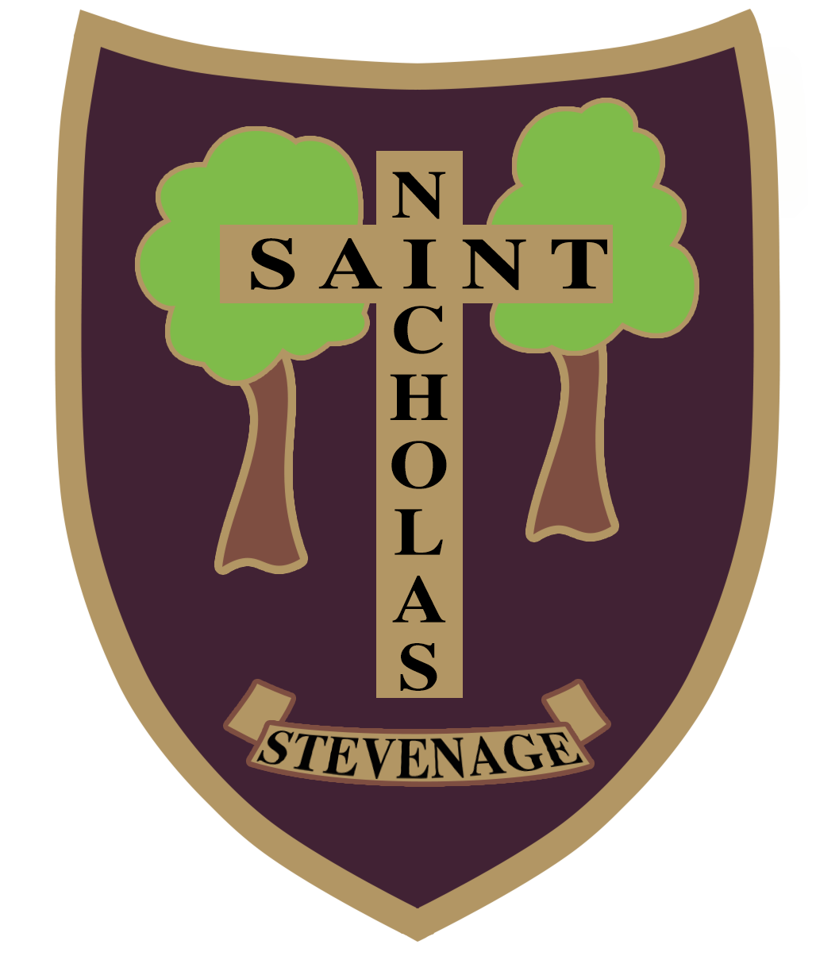

Learning, Loving, Living in God’s Family

Learning in God’s Family
Telephone: 01438 352706
E mail: admin@stnicholas120.herts.sch.uk
Website: www.stnicholas120.herts.sch.uk
Six Hills Way, Stevenage, Herts, SG2 0PZ

Headteacher: Mrs Lorraine Collins MA, BA (hons)

To Whom it may concern,

The Parent named on the form is applying for a place for their child at St Nicholas School.

In order for their child to be categorised as a church attendee we would be grateful if you could complete the attached Supplementary Information Form to support their application.

We may need to contact you to verify the information so please provide your contact details on the form.

Please note that due to the circumstances of the Covid-19 pandemic, the requirements relating to attendance during the period specified will only apply to the time when the church or, in relation to those of other faiths, relevant place of worship or alternative premises have been available for public worship.

Thank you for your help with this.

Yours sincerely

Mrs L Collins
Headteacher

Stevenage St Nicholas Primary School and Nursery

SUPPLEMENTARY INFORMATION FORM FOR THOSE CLAIMING CHURCH ATTENDANCE

Clergy are asked to complete and sign this form to assist the Governors in ensuring that those most qualified for admission under Categories 4, 5 and 6 are properly considered. Please note that priority will be based on the parents’ or carers’ links with the church and not just the child’s membership.

The relevant criteria, in priority order for the offering of places, are as follows: -

Category 4 Children of practising Anglicans, one or more of whose parents/carers have, at the time of application, shown commitment to the Church of England by worshipping at least twice a month for the two years immediately prior to an application being made. Applicants in this category are required to provide evidence in the relevant section of the SIF duly completed by their Parish Priest. Applicants in this category should note there is an expectation that the family will continue to attend church after admission to the school.

Category 5 Children from practising families of other Christian denominations, one or more of whose parents/carers have, at the time of application, shown commitment to that Place of Worship by attending at least twice a month for the two years immediately prior to an application being made. Applicants in this category are required to provide the relevant section of the SIF duly completed by their Priest, Minister or Pastor. Applicants in this category should note there is an expectation that the family will continue to attend church after admission to the school.

Category 6 Children from families of other established World Faiths whose parents/carers have , at the time of application, shown commitment to that place of worship by attending at least twice a month for the two years immediately prior to an application being made. Applicants in this category are required to provide the relevant section of the SIF duly completed by their religious leader. Applicants in this category should note there is an expectation that the family will continue to attend their place of worship after admission to the school.

Family Information

Name of Child in full....................................................................................................................................

Name of Parents or Carers..........................................................................................................................

Child’s Permanent Home Address.............................................................................................................

Church Information

Name and Denomination of Church or place of worship..............................................................................

Address...........................................................................................................................................................

…………………….………………………………………………………………………………………………………...

Name of Priest or Minister.............................................................................................................................

Position in Church............................................. ….. Contact Telephone No. ......................................

Is this Church a member of Churches together in England or the Evangelical Alliance or who profess Trinitarian Faith?

YES / NO (Delete as appropriate).

I confirm that this family has regularly worshipped at this Church at least twice a month for a minimum of two years immediately prior to the date of this application.

Signature of Priest or Minister.................................................................... Date..........................................

Please Print Name…………………………………………………………………..

